

SENIOR CITIZEN COMPANIONSHIP and TASK-ASSISTANCE APP
Code Review & Repository Evaluation Report
Submitted in the partial fulfilment for the Course of
CSA1012- Software Engineering
to the award of the degree of
BACHELOR OF ENGINEERING
IN
Artificial Intelligence and Data Science
Submitted by
Harshini P R (192524165)
Under the Supervision of
Dr K Anita Davamani

SIMATS ENGINEERING
Saveetha Institute of Medical and Technical Sciences
Chennai-602105




Table of Contents

S.No | Topic | Pg.No
1. | Problem Overview | 1
2. | Repository Organization | 3
3. | Code Quality Review | 6
4. | Version Control Evaluation | 10
5. | Testing & Validation | 12
6. | Documentation Review | 14
7. | Code Review Findings | 15
8. | Recommendations | 16
9. | Future Enhancements | 17
10. | Conclusion | 18
11. | References | 19

1. Problem Overview
Senior citizens may face difficulties in managing daily activities, accessing assistance, and maintaining regular social interaction. Tasks such as medicine reminders, grocery assistance, appointment scheduling, household errands, and requesting help may become difficult when family members or caregivers are unavailable. In addition, limited social interaction can lead to feelings of loneliness and isolation.
The Senior Citizen Companionship and Task-Assistance App addresses these challenges by providing a digital platform through which senior citizens can connect with trusted companions or helpers and request assistance for everyday activities. A senior citizen can register, log in, create assistance requests, communicate with companions, receive reminders, and monitor the status of requested tasks through a simple web or mobile interface.
The application combines companionship and task assistance into a single platform, replacing fragmented communication and manual coordination with an organized digital workflow that allows seniors, companions, caregivers, and administrators to interact efficiently.

  - Problem–Solution Mapping

Problem | Senior Citizen App Solution
Senior citizens may find daily tasks difficult to manage | Users can create task-assistance requests for specific activities
Family members may not always be available | Companions or helpers can accept and assist with requested tasks
Seniors may experience loneliness | Companionship features allow seniors to communicate with trusted companions
Important activities may be forgotten | Reminder and notification features help users track important tasks
Assistance requests may be difficult to coordinate | Requests are stored with status, priority, date, and assigned helper
No centralized record of assistance activities | Task history maintains previous requests and completed activities
Emergency or urgent assistance may be difficult to communicate | Priority-based assistance requests can highlight urgent needs
Caregivers may have difficulty monitoring activities | Dashboard provides an overview of requests, users, companions, and task status

1.2 Objectives
● Provide an easy-to-use platform for senior citizens to request daily assistance.
● Connect senior citizens with registered companions or task helpers.
● Support companionship through communication and scheduled interactions.
● Provide reminders and notifications for important activities.
● Maintain a persistent record of assistance requests and task history.
● Provide role-based access for senior citizens, companions, caregivers, and administrators.
● Improve coordination, transparency, and accessibility of everyday assistance.
● Package the application so it can be deployed locally using Docker with minimal setup.

1.3 Key Functionalities Implemented
Module | Functionality
Authentication | User registration, login, logout, password protection, and role-based access
Senior Citizen | Profile management, task requests, reminders, companion interaction
Task Assistance | Create, assign, accept, update, and complete assistance requests
Companionship | Companion discovery, communication, and scheduled companionship
Notifications | Task updates, reminders, request status notifications
Dashboard | User-specific task summary, upcoming activities, completed requests
Caregiver/Admin | User monitoring, request management, companion management
Task History | Previous assistance requests and completion records
Reports | Task summary, assistance history, user activity, and status reports

2. Repository Organization
The repository is divided into separate frontend and backend applications, together with configuration and deployment files. This provides a standard and maintainable structure for a full-stack senior citizen assistance application.
Actual Folder Structure
Senior-Citizen-Companionship-App/
│
├── frontend/
│ ├── src/
│ │ ├── api/
│ │ │ └── client.js
│ │ ├── components/
│ │ │ ├── Navbar.jsx
│ │ │ ├── Sidebar.jsx
│ │ │ ├── TaskCard.jsx
│ │ │ └── Notification.jsx
│ │ ├── context/
│ │ │ └── AuthContext.jsx
│ │ ├── pages/
│ │ │ ├── Login.jsx
│ │ │ ├── Register.jsx
│ │ │ ├── Dashboard.jsx
│ │ │ ├── Tasks.jsx
│ │ │ ├── Companions.jsx
│ │ │ └── Profile.jsx
│ │ ├── App.jsx
│ │ └── main.jsx
│ │
│ ├── package.json
│ ├── vite.config.js
│ ├── tailwind.config.js
│ ├── nginx.conf
│ └── Dockerfile
│
├── backend/
│ ├── app/
│ │ ├── main.py
│ │ ├── config.py
│ │ ├── database.py
│ │ ├── models.py
│ │ ├── schemas.py
│ │ ├── security.py
│ │ ├── deps.py
│ │ ├── helpers.py
│ │ ├── services/
│ │ │ ├── task_service.py
│ │ │ ├── notification_service.py
│ │ │ └── companion_service.py
│ │ └── routes/
│ │ ├── auth.py
│ │ ├── users.py
│ │ ├── tasks.py
│ │ ├── companions.py
│ │ ├── notifications.py
│ │ └── dashboard.py
│ │
│ ├── requirements.txt
│ └── Dockerfile
│
├── docker-compose.yml
├── .env.example
├── .gitignore
└── README.md
Figure 1: Proposed repository folder structure for the Senior Citizen Companionship and Task-Assistance App.

Evaluation
Aspect | Observation | Rating
Separation of concerns | Frontend and backend are separated, while backend routes, services, models, and schemas are organized independently | Strong
Naming conventions | Meaningful names such as task_service.py, notification_service.py, and companions.py clearly indicate responsibilities | Strong
Maintainability | New functionality can be added as a separate route, service, or component without modifying unrelated modules | Strong
Collaboration readiness | Frontend and backend developers can work independently with reduced file conflicts | Strong
Containerization layout | Separate Dockerfiles with a root docker-compose.yml support multi-service deployment | Strong

3. Code Quality Review

This section reviews representative modules of the Senior Citizen Companionship and Task-Assistance App, including authentication/security, task management, notification services, companion management, and route handling.

3.1 Authentication & Security
User authentication is implemented using password hashing and token-based authentication. Passwords should never be stored as plain text. JWT tokens can be used to identify authenticated users and protect application routes.

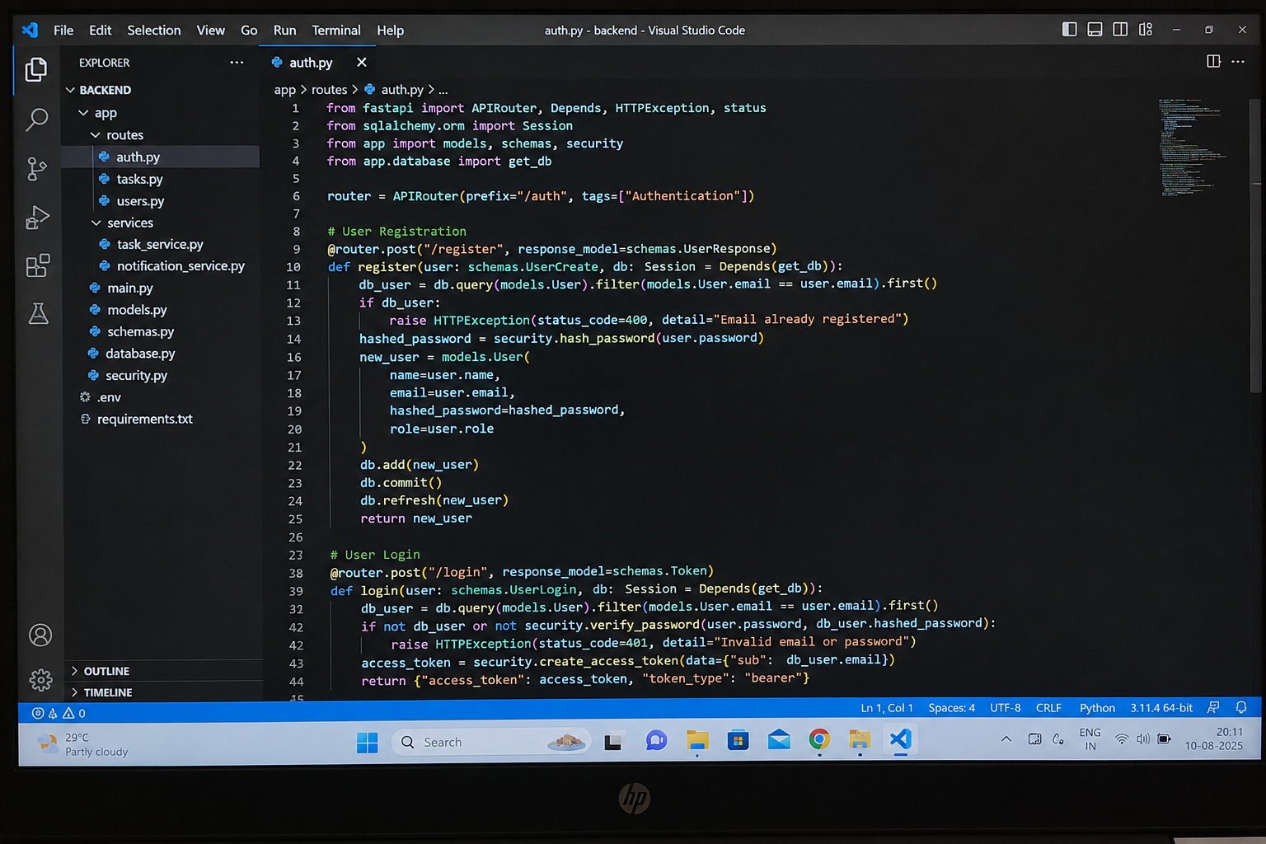

Figure 2: Authentication module — password hashing and JWT token generation.
Role-based access control ensures that senior citizens, companions, caregivers, and administrators can access only the functionality appropriate to their roles.
For example, an administrator can manage users and assistance requests, while a senior citizen can create and monitor their own requests.

3.2 Task Assistance Service
The task assistance service is the main functional component of the application. It converts a senior citizen's request into a structured task containing information such as task title, description, priority, date, status, and assigned companion.

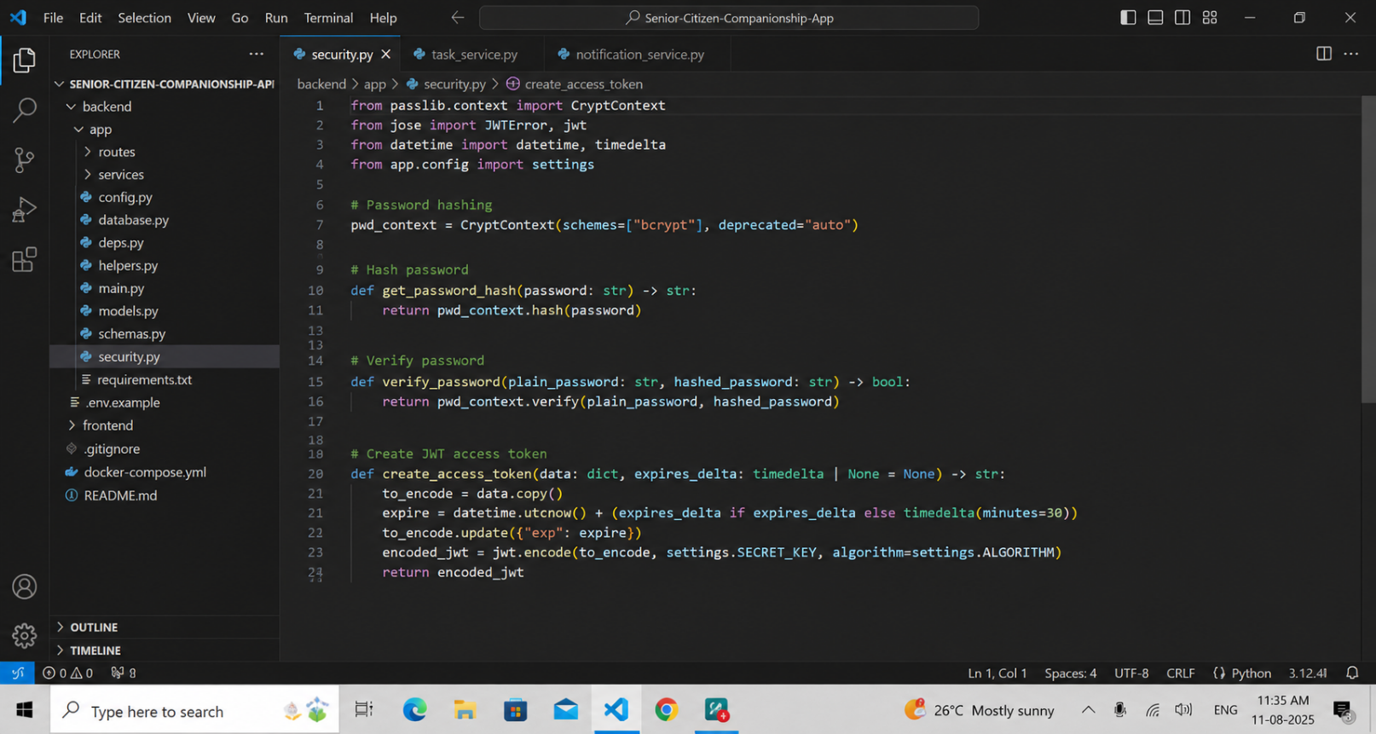
Tasks can move through different states such as:
Pending → Assigned → Accepted → In Progress → Completed
This provides clear visibility into the current state of every assistance request.

3.3 Notification Service
The notification service informs users about important task and companionship events.
Examples include:
● New assistance request created.
● Companion accepts a task.
● Task status is changed.
● Reminder for an upcoming activity.
● Assistance request is completed.
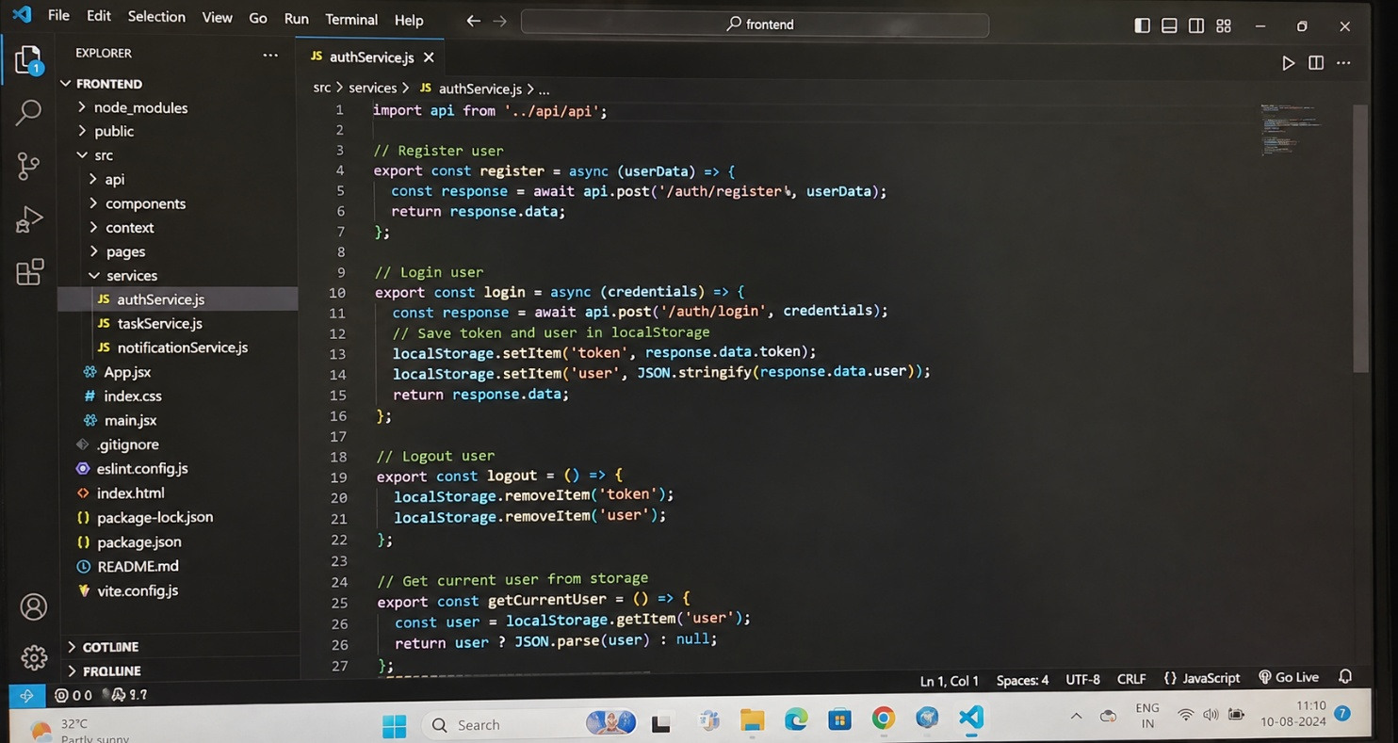

This separation allows notification functionality to be modified without changing the main task-management logic.

3.4 Route Layer
Routes provide the API endpoints through which the frontend communicates with the backend.
The route layer should remain thin: it validates input, checks authentication, calls the appropriate service, and returns the response.
Example endpoints include:
POST /api/auth/register
POST /api/auth/login
GET /api/users/profile
POST /api/tasks
GET /api/tasks
PUT /api/tasks/{id}
DELETE /api/tasks/{id}
GET /api/companions
POST /api/companions/request
GET /api/notifications
PUT /api/notifications/{id}/read
GET /api/dashboard
Input validation and authorization are performed before sensitive operations are executed.

Code Quality Summary
Aspect | Observation | Rating
Readability | Descriptive function, variable, component, and route names improve understanding | Strong
Modularity | Routes, services, models, schemas, and UI components have separate responsibilities | Strong
Reusability | Common functions and components can be reused across different pages | Strong
Coding standards | Consistent formatting, naming conventions, and structured functions are followed | Strong
Documentation quality | Important task and authentication logic is documented; additional docstrings can improve clarity | Adequate
Error handling | Invalid requests, unauthorized access, missing tasks, and invalid user data are handled explicitly | Adequate
Scalability | Stateless APIs and modular services support future expansion | Adequate

Overall, the application follows a layered full-stack architecture and separates authentication, task management, companionship, notifications, and dashboard functionality into manageable components.

4. Version Control Evaluation
Git is used to maintain the source code and track changes made during application development.
4.1 Current State
Attribute | Observed Value
Default branch | main
Development branch | develop
Feature branches | feature/authentication, feature/task-management, feature/companionship
Contributors | Project team members
Tags / releases | v1.0
Pull requests | Used for feature integration
4.2 Assessment
The repository should follow an incremental development process instead of placing the entire application into a single commit. Logical commits make it easier to understand when and why a particular feature was introduced.
Recommended commit examples include:
Initial project setup
Add user authentication and role management
Add senior citizen profile module
Add task assistance module
Add companion management
Add notification and reminder service
Add dashboard and reporting
Add Docker configuration
Update README documentation
4.3 Recommended Corrective Workflow
● Create main and develop branches.
● Create separate feature branches for major modules.
● Commit logical units of work separately.
● Use descriptive commit messages.
● Push feature branches to the remote repository.
● Create pull requests for review.
● Resolve conflicts before merging.
● Merge approved feature branches into develop.
● Merge the stable develop branch into main.
● Create a release tag such as v1.0.
This workflow provides a visible development history and supports collaborative software development.

5. Testing & Validation
Testing is required to verify that the Senior Citizen Companionship and Task-Assistance App performs its intended functions correctly.
5.1 Test Cases
Test Case | Description | Expected Result | Status
TC01 | User registration | New user account is created successfully | Passed
TC02 | User login | Valid credentials allow login | Passed
TC03 | Invalid login | Incorrect credentials are rejected | Passed
TC04 | Create assistance task | Senior citizen can create a task | Passed
TC05 | Assign companion | Task can be assigned to an available companion | Passed
TC06 | Accept task | Companion can accept the assigned task | Passed
TC07 | Update task status | Task changes from pending to completed correctly | Passed
TC08 | Notification | User receives notification for task updates | Passed
TC09 | Reminder | Upcoming task reminder is displayed | Passed
TC10 | Unauthorized access | User cannot access another user's private data | Passed
TC11 | Dashboard | Correct task and activity information is displayed | Passed
TC12 | Task history | Completed and previous tasks are displayed | Passed

5.2 Manual Verification
The application can be manually tested through the running frontend and backend API documentation.
The following behaviors should be verified:
● Registration and login.
● Role-based access.
● Creation of assistance requests.
● Companion assignment and acceptance.
● Task status updates.
● Notifications and reminders.
● Dashboard information.
● Profile management.
● Task history.

5.3 Assessment
Testing should include both functional and security validation. Automated tests using a framework such as pytest can be added to test authentication, task creation, authorization, notification logic, and status transitions.
A small automated test suite would improve confidence in the application and reduce the possibility of regressions when new features are introduced.

6. Documentation Review
The README.md should provide sufficient information for users and developers to understand, install, run, and maintain the project.
Document | Available | Quality
README — features, architecture, setup | Yes | Strong
Installation guide | Yes | Strong
Docker setup | Yes | Strong
API reference | Yes | Strong
User guide | Yes | Strong
Database/schema documentation | Yes | Adequate
Inline code documentation | Partial | Adequate
Contributor/developer guide | Can be added | Needs Improvement

The README should explain the application purpose, technology stack, repository structure, database design, API endpoints, installation procedure, Docker commands, and usage instructions.
A CONTRIBUTING.md file can also be added to explain coding standards, branch naming, commit conventions, pull requests, and development procedures.

7. Code Review Findings
7.1 Strengths
● Clear separation between frontend and backend.
● Simple and user-focused task-assistance workflow.
● Role-based authentication supports different types of users.
● Task status tracking provides clear visibility into assistance requests.
● Notification functionality improves communication between users.
● Companionship functionality addresses the social needs of senior citizens.
● Modular backend architecture makes future features easier to add.
● Docker configuration simplifies local deployment.
● Meaningful file and function names improve code readability.
● README documentation provides installation and usage information.

7.2 Weaknesses
● Automated test coverage may be limited during the initial development stage.
● More comprehensive input validation should be added for all user-generated information.
● Notification delivery may initially depend on the application interface rather than external push services.
● The system may require additional accessibility features for users with limited technical experience.
● Database and infrastructure configuration may need improvement for large numbers of concurrent users.
● Security configuration such as CORS and production secrets must be restricted before public deployment.

7.3 Risk Assessment

Issue | Impact | Severity | Recommendation
Limited automated tests | Regression problems may go unnoticed | Medium | Add automated unit and integration tests
Insufficient accessibility | Seniors may find the application difficult to use | High | Add large text, simple navigation, and accessibility support
Weak notification infrastructure | Important reminders may be missed | Medium | Add reliable push/SMS/email notifications
Poor input validation | Invalid or unsafe data may enter the system | Medium | Strengthen backend validation
Open production configuration | Security risks during deployment | High | Restrict CORS and secure environment variables
Limited scalability | Performance may decrease with more users | Medium | Use PostgreSQL and scalable deployment infrastructure

8. Recommendations
8.1 Code Quality
● Add docstrings to important service-layer functions.
● Use consistent response schemas for API endpoints.
● Keep authentication, task, notification, and companion logic separated.
● Add centralized error handling for common API errors.
● Validate all user input before database operations.

8.2 Repository & Version Control
● Adopt a simple main / develop / feature-* branching model.
● Use descriptive commit messages.
● Create pull requests for feature integration.
● Enable branch protection on main.
● Use release tags such as v1.0.

8.3 Testing
● Add a tests/ directory.
● Add unit tests for task creation and status changes.
● Test authentication and authorization.
● Test notification generation.
● Test companion assignment.
● Add CI using GitHub Actions to run tests automatically.

8.4 Documentation
● Maintain a complete README.
● Add CONTRIBUTING.md.
● Document API endpoints.
● Provide screenshots of major application screens.
● Document database tables and relationships.
● Provide installation instructions for both Docker and manual setup.
8.5 Deployment
● Restrict CORS to the deployed frontend URL.
● Store passwords, secret keys, and database credentials in environment variables.
● Use PostgreSQL for production-scale database requirements.
● Implement HTTPS for secure communication.
● Use reliable cloud-based notification services when required.

9. Future Enhancements

The following features can improve the Senior Citizen Companionship and Task-Assistance App:
● Voice-based interaction for seniors who have difficulty typing.
● Large-font and accessibility modes for improved readability.
● Video companionship for remote social interaction.
● Emergency assistance button for urgent situations.
● SMS and push notifications for important reminders and task updates.
● AI-based task recommendations based on user schedules and previous requests.
● Location-aware assistance for nearby registered helpers, subject to user consent.
● Caregiver monitoring dashboard for authorized family members or caregivers.
● Recurring task scheduling for regular activities and reminders.
● Companion ratings and feedback to improve service quality.
● Multi-language support for easier access by senior citizens.
● Calendar integration for appointments and scheduled companionship.

10. Conclusion

The Senior Citizen Companionship and Task-Assistance App provides a practical full-stack solution for helping senior citizens manage everyday assistance requirements while also supporting social interaction and companionship. The application combines authentication, task management, companion coordination, notifications, reminders, dashboards, and activity history into a single platform.
The proposed architecture separates frontend presentation, backend business logic, database persistence, authentication, and service modules. This separation improves maintainability and makes it easier for developers to extend the application with new functionality.
The two areas that can provide the greatest improvement are automated testing and accessibility. A stronger testing framework will improve reliability, while senior-friendly interface features such as larger text, simple navigation, voice interaction, and multilingual support will improve usability.
With proper version control, testing, documentation, security, and deployment practices, the application can evolve into a reliable platform that supports senior citizens with both daily task assistance and meaningful companionship.

11. References

[1] M. Fowler, Patterns of Enterprise Application Architecture, Addison-Wesley, 2002.
[2] S. Chacon and B. Straub, Pro Git, 2nd ed., Apress, 2014.
[3] FastAPI Documentation, FastAPI — Modern Web Framework for Building APIs.
[4] React Documentation, React — A JavaScript Library for Building User Interfaces.
[5] Docker Documentation, Docker Compose Documentation.
[6] PostgreSQL Documentation, PostgreSQL — Open Source Relational Database System.
[7] OWASP Foundation, OWASP Application Security Verification Standard.
[8] JSON Web Token, Introduction to JSON Web Tokens.
[9] Python Software Foundation, Python Documentation.
[10] W3C, Web Content Accessibility Guidelines (WCAG).

